China Media Centre 2013 Autumn Seminar
THE HIGHS AND LOWS OF REPORTING FROM CHINA
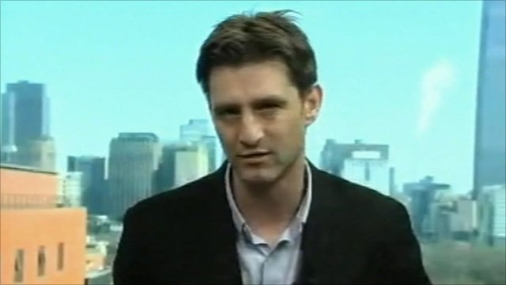
Speaker: Michael Bristow
Date: Wednesday 20th November
Time: 2-4pm
Venue: A1.06
Chair: Professor Hugo de Burgh

OPEN TO ALL

The highs and lows of reporting from China – Michael Bristow talks about his time in Beijing as a journalist for the BBC and the China Daily.

Michael Bristow has been a journalist for 20 years, starting out as a newspaper reporter and then moving into broadcasting. He's reported from Taiwan and more recently from China. He left Beijing last year after spending five years there as a correspondent for the BBC, appearing on TV and radio and writing for the news website.
He had previously worked for the China Daily on two separate occasions totalling two years. Michael now works in the new BBC headquarters in London as a regional editor - for East Asia and the Pacific - on the World Service.

More about China Media Centre and seminars see http://chinamediacentre.org/
If you have any inquiry about CMC events, please contact Alja Kranjec at A.Kranjec@westminster.ac.uk

