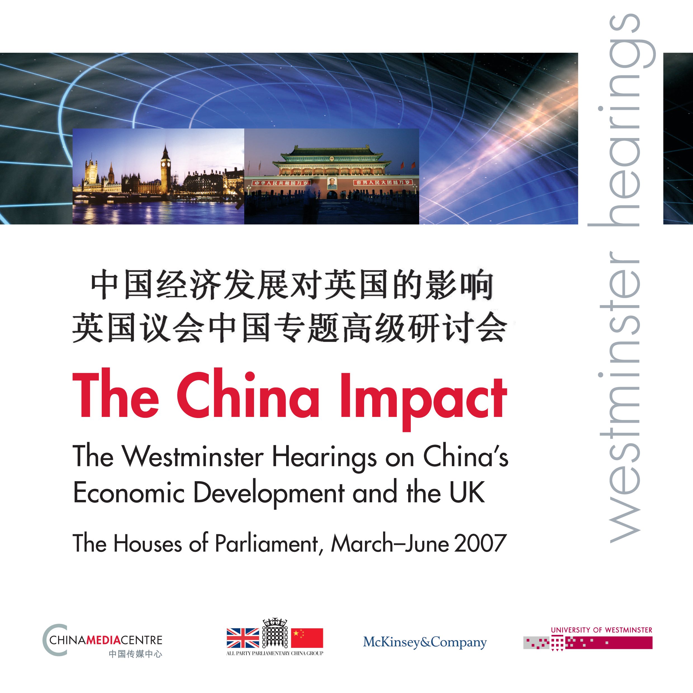

21 March 2007
CHINA POWER

PROGRAMME

The implications of China’s energy challenge. The most innovative business solutions to global geopolitical and energy challenges. The 11th five year plan emphasises energy efficiency, giving impetus to businesses to work in China to develop and implement clean technologies and energy efficient projects.

08.30 Arrival Attlee Suite Breakfast Served
08.45 Start Plenary Session
09.30 Workshops
11.00 Attlee Suite Refreshments
11.10 Plenary Session: Summing-up from the workshops and Conclusion
11.45 End

PLENARY SESSION

Room: Attlee Suite

CHAIR
Ben Chapman MP, Chairman, All-Party Parliamentary Group on China

WELCOME
Ian Pearson MP, Minister of State for Climate Change and Environment

LEAD SPEAKERS
Zhou Dadi, Energy Commissioner, National Development and Reform Commission

The Rt Hon John Gummer MP, Chairman, OECD Environment Committee，Lately Secretary of State for the Environment; Chairman, Conservative Party Quality of Life Policy Group; Chairman, Veolia Water UK

WORKSHOPS

- Geopolitics of Resources – Room Attlee Suite

How do China’s resource needs, policies and practices impact on the UK?

CHAIR
Jonathan Fenby, Editor in Chief of Trusted Sources. Formerly editor of The Observer, The South China Morning Post, Reuters World Service and The Economist.

LEADS
Stephanie T. Kleine-Ahlbrandt, International Affairs Fellow, Council on Foreign Relations
Dr Cho Khong, Chief Political Analyst SXE, Shell International

- Innovative investment opportunities – Room N

How can UK companies and investors take part in China’s clean energy and water revolutions? What are the opportunities for UK SMEs to partner with big business in innovating in clean technologies in China?

CHAIR
Wang Tao, Head of Asia Economics, BP Group

LEADS
Peter Head, Director, Arup
Bill Dunster, Principal 'the ZEDfactory', BedZED

- China’s Environment : Challenges and Opportunities – Room M

The longstanding problems China faces in its environment are being compounded by its rapid and successful economic development. What are likely to be the effects of these upon its relations with other countries? Does the UK have relevant expertise and experience in tackling environmental problems? Can UK companies work in waste management and water systems to help service China’s growing water challenge? Or in pollution control? What are the most innovative business solutions to global geopolitical and energy challenges?

CHAIR
John Ashton, Special Representative for Climate Change, FCO

LEADS
Dr Wang Aijuan, Head of China Business, Mott MacDonald Group
David Fortune, Director of Product Management, Wallingford Software
Mark Lane, Head of Water Sector Group, Partner Pinsent Masons

